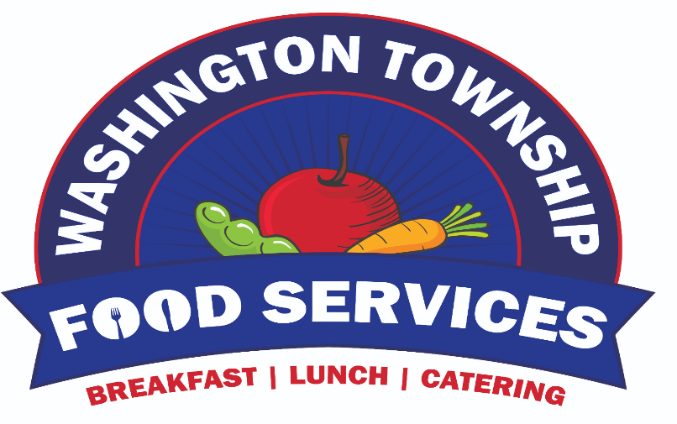

CATERING MENU

Contact Information

Jennifer Mullin, Food Service Manager

(856) 582-4010 OR X4282

Email jmullin@wtps.org

At Washington Township Catering our, goal is to make planning your event as easy as possible.

All our packages and options are customizable to meet your needs and budget.

All packages include paper products and plastic ware.

TWP Cheese Steak Menu

Cheese Steaks with American Cheese

Chicken Cheese Steaks with American Cheese



Peppers and Onions

Nachos with Cheese and Salsa

Pasta or Caesar Salad

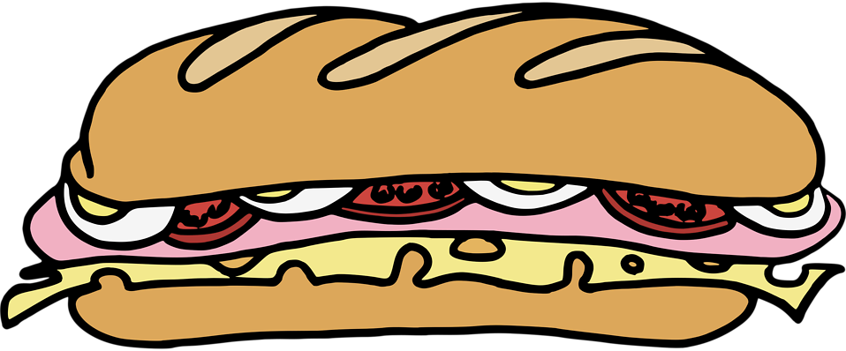Cookie and Brownie Tray

TWP Taco Bar Menu

Make Your Own Tacos or Nachos

Served Buffet Style with the Following:

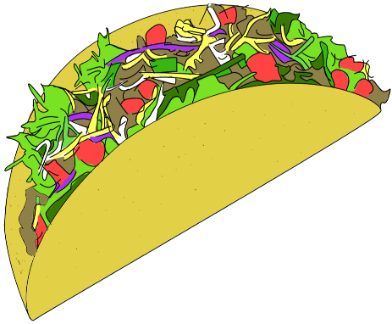

[This Photo](http://commons.wikimedia.org/wiki/File:Taco_detailed_icon.png) by Unknown Author is licensed under [CC BY-SA](https://creativecommons.org/licenses/by-sa/3.0/)

Seasoned Ground Beef

Fajita Seasoned Chicken

Brown Rice with or without Beans

Shredded Blend Cheese

Sour Cream

Salsa

Tortilla Chips OR Soft and Hard Shells



Shredded Lettuce and Diced Tomatoes

Brownie and Cookie Tray

TWP Slider Menu

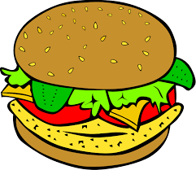TWP Cheeseburger Sliders

or

BBQ Pulled Pork Sandwiches

w/ Provolone Cheese

or

TWP Buffalo Chicken Sliders

Or

Italian Hoagie Dip Served with Fresh Rolls

Choice of 2

Pretzel Tray with Mustard

Pasta or Caesar Salad

Cookie and Brownie Tray





TWP Dinner Menu

TWP Chicken with Roasted Peppers and Provolone

or

Roasted Turkey w/ Gravy

or

Chicken Parmesan

or

Stuffed Shells

or

Baked Rigatoni

Choice of 2

Roasted Red Skin Potatoes or Mashed Potatoes

Mixed Vegetables or Roasted Broccoli

Caesar Salad

Cookie and Brownie Tray

Assorted Cookie Trays

Sugar, Chocolate Chip, Double Chocolate Chip, Oatmeal Raisin, M and M, Turtle, White Chocolate Macademia

Large Cookies Tray 7 Dozen Cookies $40

Medium Tray 5 Dozen Cookies $30

Small Tray 3 Dozen Cookies $20



Coffee Service

Includes Tea, Hot Water, Creamers, Etc.

Danish, Muffins, Bagels with Assorted Spreads and Cookies



Ice Cream Socials

Various Ice Cream Flavors with Toppings



Bagged Lunches for Sports and Activities

Gatorade, PBJ Uncrustable, Granola Bar and a Piece of Fruit $4.00

Water, PBJ Uncrustable, Granola Bar and a Piece of Fruit $3.50

BAGS CAN BE CUSTOMIZED IF PRE-ORDERED